**Name:** Mohamed Ebrahim Mohamed Saby

**B.N: 637**

**Date:4/6/2020**

**Topic:** Database Systems

**GitHub link:**

**GitHub page:**

**Application brief:**

Thermal analysis methods such as DSC, TG, or DIL are usually applied, for example, to determine fusion temperatures, degree of crystallization, reaction temperatures and enthalpy, specific heat capacity, and thermal stability of materials or their thermal expansion so that many information systems aim at transferring data To information in order to generate knowledge that can be used for decision-making.

To do this, the system must be able to take data, put data in context, and provide tools for collection and analysis. A database is designed for this purpose only.

However, certain stages are revealed or confirmed where special chemical compounds such as salts show distinct DSC peaks due to fusion or other phase shifts. Another example is material characterization in relation to quality and failure analysis where DSC and TG allow detection, and in some cases.

The database is an organized collection of related information. It is an organized group, because in the database all data is described and linked to other data. All information in the database must also be relevant. Separate databases must be created to manage irrelevant information. Certainly, identifying completely unknown samples is not the main purpose of conventional thermo-analysis techniques such as DSC, TG, or DIL - at least when not paired with any advanced gas analysis. There is a more frequent application, for example, for standalone DSC and TG devices. For example, a database that contains student information should not contain information about company stock prices. Databases are not always digital - for example, file cabinet can be considered a form of database. For the purposes of this text, we will only consider digital databases.

Databases can be organized in several different ways, and thus take many forms. The most common database today is a relational database. Common examples of relational databases are Microsoft Access, MySQL, and Oracle. A relational database is where data is organized into one or more tables. Each table contains a set of fields that determine the nature of the data stored in the table. A record is one instance of a group of fields in a table. To visualize this, think of records as table rows and fields as table columns. In the example below, we have a table with student information, where each row represents a student and each column represents one piece of student information.

Unwanted components or impurities present in the sample are identified [16]. In this case, additional effects were observed in the DSC or TG signals, or the expected effects were changed compared to the pure substance.

In general, the *Identify* database system always contains all of the NETZSCH database entries and offers the possibility of overlaying an “unknown” measurement with any database curve—including those of other supported signal types. Users can create libraries containing their own data that can also be shared with several other users at the same time in the computer network.

Many times, when introducing the concept of databases to students, they quickly decide that a database is pretty much the same as a spreadsheet. After all, a spreadsheet stores data in an organized fashion, using rows and columns, and looks very similar to a database table. This misunderstanding extends beyond the classroom: spreadsheets are used as a substitute for databases in all types of situations every day, all over the world.

## Screenshots:

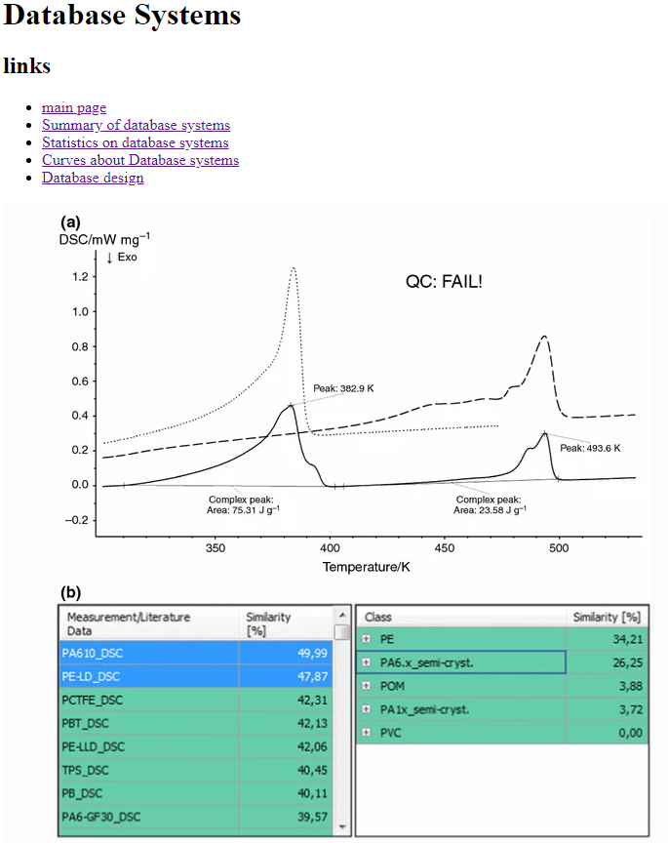

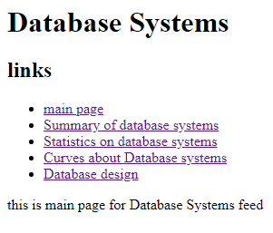

**Source code:**

